#### INTRODUCTION

* 1. ProjectOverview
  2. Purpose

#### IDEATIONPHASE

* 1. ProblemStatement
  2. EmpathyMapCanvas
  3. Brainstorming

#### REQUIREMENT ANALYSIS

* 1. CustomerJourneyMap
  2. SolutionRequirement
  3. DataPreparation&FlowDiagram
  4. TechnologyStack

#### PROJECTDESIGN

* 1. ProblemSolutionFit
  2. ProposedSolution
  3. SolutionArchitecture

1. PROJECTPLANNING&SCHEDULING 5.1ProjectPlanning

#### FUNCTIONALANDPERFORMANCETESTING

* 1. PerformanceTesting

#### RESULTS

* 1. OutputScreenshots

1. ADVANTAGES&DISADVANTAGES
2. CONCLUSION
3. FUTURESCOPE
4. APPENDIX SourceCode(ifany) DatasetLink GitHub&ProjectDemoLink

REVOLUTIONIZINGLIVERCARE

**PredictingLiverCirrhosisusingAdvancedMachineLearningTechniques**

# INTRODUCTION

* 1. ProjectOverview

The**"RevolutionizingLiverCare"**projectisadata-drivenhealthcareinitiativethataimstotransformliver disease diagnosis and treatment using advanced machine learning techniques. The system is designed to analyze patient health records, biochemical markers, and lifestyle attributes to detect early signs ofliver disease,enablingtimelymedicalintervention.Byleveragingpredictivemodelingandclassification algorithms, the solution supports healthcare professionals in making accurate, evidence-based decisions.

This project integrates a variety of machine learning models such as Logistic Regression, K-Nearest Neighbors (KNN), Random Forest, Support Vector Machine (SVM), and XGBoost to evaluate performance and choose the most accurate model. It also focuses on visualization, feature engineering,andmodelevaluationmetricslikeprecision,recall,andF1-scoretoensurereliabilityandclinicalrelevance. The ultimate goal is to improve patient outcomes, optimize diagnosis timelines, and assist in revolutionizing liver care management.

Livercirrhosisisachronicandprogressiveliverdiseasecharacterizedbytheirreversiblescarringofliver tissue, which can lead to severe complications and liver failure ifleft untreated. This project aims to developapredictivemodelfortheearlydetectionandprognosisoflivercirrhosisusingmachinelearning techniques . The developed predictive model holds promise for early detection and prognosis ofliver cirrhosis, enabling healthcare professionals to initiate timely interventions and personalized treatment strategies.Byaccuratelyidentifyingindividualsatriskof cirrhosis,thisresearchcontributestoimproved patient outcomes and the optimization of healthcare resources. Moreover, it highlights the potential of machinelearninginthefieldofhepatology,showcasingitsabilitytoleverageclinicaldataforpredictive modeling and decision support.

* 1. Purpose

Thepurposeofthisproject isto:

Detect liver disorders early through predictive analytics.

Supporthealthcareprofessionalswithintelligentdecision-makingtools. Reduce manual diagnostic errors and delays in liver disease detection.

Enable scalable, automated liver health monitoring across healthcare facilities.

Demonstrate the effectiveness ofmachine learning in real-world clinical settings. Raiseawarenessofpreventivelivercareandtheimportanceofearlyintervention.

### IDEATIONPHASE

* 1. ProblemStatement

Liverdiseasesareagrowingglobalhealthconcern,oftendiagnosedatadvancedstagesduetoalackof timelyscreeningandeﬃcientdiagnostictools.Traditionalmethodsofdiagnosisrelyheavilyonmanual interpretationofmedicaldata,whichcanbetime-consuming,error-prone,andinconsistentacross healthcare providers.

The"RevolutionizingLiverCare"projectaimstobridgethisgapbydevelopingamachinelearning–based system capable ofaccurately predicting liver disease using patient health data. By analyzing patterns in

biochemical markers and demographic information, the system can identifyindividuals at risk and assist doctors in making quicker, more accurate diagnoses. The project leverages a combination of supervised learning models, data visualization, and performance evaluation techniques to build a clinically viable, intelligent diagnostic assistant.

Thisinnovativeapproachtolivercareisdesignedtoreducediagnosticdelays,enhancedecision-makingin hospitals and clinics, and ultimately improve patient outcomes through proactive healthcare.

* 1. EmpathyMapCanvas

## Says:-

"I need quick and accurate diagnostic support."

"Idon’thavetimetoanalyzeeverydetailmanually.""Early detection is crucial in liver disease cases."

"I want data-backed decisions I can trust.""Technologyshouldassist,notcomplicate."

## Thinks:-

"AmImissingearlysignsof liverdamageinsomepatients?""IwishIhadasmarterwaytoscreenpatientsautomatically.""Willthissystembereliableenoughinreal-worldscenarios?""How can I reduce human error in diagnoses?

* 1. Brainstorming

During the ideation phase ofthis project, a brainstorming session was conducted to explore various anglesandinnovativeideasthatcouldenhanceliverdiseasediagnosisusingmachinelearning.Theteam considered clinical, technical, and user-centric aspects to define a well-rounded solution.

Usesupervisedlearningmodelslike: Logistic Regression

Random Forest

KNN SVM

XGBoost

### REQUIREMENTANALYSIS

* 1. CustomerJourneyMap

|  |  |  |
| --- | --- | --- |
| **Stage** |  | **Opportunities** |
| Awareness |  | Demonstrateproven success, clear benefits, and easy integration. |
| Consideration |  | Provide interactive demo, training material,andsecurity assurance. |
| Onboarding |  | Offer guided onboarding, live support, and confidence-building feedback. |
| Usage |  | Continuously improve UI/UX and offer responsive support. |
| Evaluation |  | Share validation metrics, regular updates,anduser case studies. |
| Advocacy |  | Enablesharingof success stories, incentives for referrals. |

**Actions**

Learns about the AI-basedlivercare system from colleagues or conferences.

Views a demo, reads documentation,or consults IT team.

Starts using the system on a trial basis with patient data.

Inputs patient lab values into the system to get predictionresults.

Comparessystem predictions with actual diagnoses.

**Thoughts**

“Can this really help me with earlydiagnosis?”

“Isthiseasyto use and worth adopting?”

“I hope it doesn’t complicatemy workflow.”

“Thisissaving

metimeandConfident, supporting mysupported decisions.”

“It’saccurate.I

cantrustthis tool.”

“Everyclinic should have this.”

**Feelings**

Curious, skeptical

Interested, cautious

Hopeful, cautious

**PainPoints**

Toomanytools claim accuracy butlackclinical value.

Concerns about timeinvestment,data security, and training needs.

Learningcurve, doubts about prediction accuracy.

Occasionaltech glitches or confusing UI.

Needsevidence over time to fully trust.

Others may hesitatedueto lack of awareness.

Reassured,

impressed

Empowered, satisfied

* 1. SolutionRequirement

The goal ofthis project is to build a robust, scalable, and intelligent liver disease prediction system using machinelearning.Belowarethecategorizedsolutionrequirementsthatdefinethetechnicalandfunctional needs of the system.

## FunctionalRequirements

1.DataInputInterface

Acceptspatientdata(e.g.,age,gender,biochemicaltestresults)throughCSVuploadorformentry. 2.Preprocessing Module

Handles missing values, normalizes input data, and prepares it for model training or prediction.

## Non-functionalRequirements

1.Accuracy&Reliability

□Modelperformanceshouldexceedbaselineclinicaldiagnosticmethodsintermsof sensitivityandspecificity.

* 1. DataPreparation&FlowDiagram

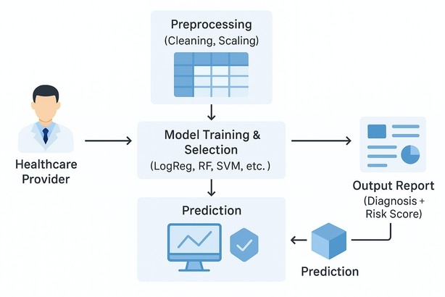

The data flow diagram for the "Revolutionizing Liver Care" project illustrates the end-to-end process of using machine learning to assist in liver disease diagnosis. It begins with the healthcare provider, typically a doctor or clinician, who inputs patient data such as liver function test results, age, and other medical attributes. This data is sent to the preprocessing module, where it undergoes cleaning and normalization to prepare it for analysis. Once preprocessed, the data enters the model training and selection phase, where multiple machine learning algorithms like Logistic Regression, Random Forest, and SVM are evaluated to determine the most accurate and eﬃcient model. The selected model then performs predictions to assess whether a patient is at risk ofliver disease. These predictions are forwarded to the output report module, where results are presented in a user-friendly format, including the diagnostic decision and a risk score.

This structured flow ensures that the system is not only technically sound but also clinically valuable. It reduces manual diagnostic effort, minimizes human error, and provides consistent results. The diagram emphasizes the seamless integration between data, model, and user. Each step is designed to ensure accuracy,speed,andclarityforhealthcareprofessionals.Byautomatingthediagnosticpipeline,thesystem empowers doctors with reliable insights. It also supports early detection and timely treatment planning.

Overall,theDFDencapsulatestheproject'sgoaltomakelivercaresmarter,faster,andmore**accessible.**

### DataPreparation

Aswehaveunderstoodhowthedatais,let'spre-processthecollecteddata.

The download data set is not suitable for training the machine learning model as it might have so much randomnesssoweneedtocleanthedatasetproperlyinordertofetchgoodresults.Thisactivityincludes the following steps.

Handling missing valuesHandlingcategoricaldata Handling Outliers

##### HandlingMissingValues

Let’sfindtheshapeofourdatasetfirst.Tofindtheshapeofourdata,thedf.shapemethodisused.Tofind the data type, df.info() function is used.

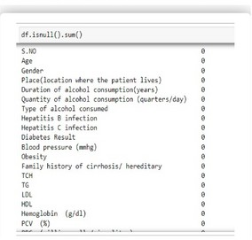

Forcheckingthenullvalues,df.isnull()functionisused.Tosumthosenullvaluesweuse.sum()function. From the below image we found that there are no null values present in our dataset. So we can skip handling the missing values step.

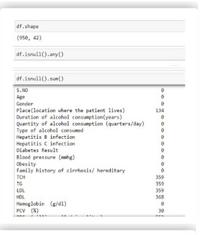

##### HandlingCategoricalValues

Aswecanseeourdatasethascategoricaldatawemustconvertthecategoricaldatatointegerencodingor binary encoding.

Toconvertthecategoricalfeaturesintonumericalfeaturesweuseencodingtechniques.Thereareseveral techniques but in our project we are using manual encoding with the help oflist comprehension.

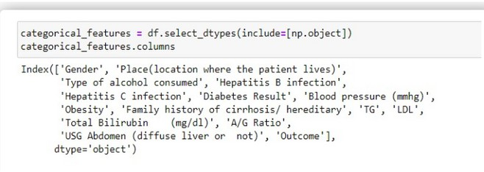

##### HandlingOutliersin Data

With the help ofboxplot, outliers are visualized. And here we are going to find upper bound and lower bound of numerical features with some mathematical formula.

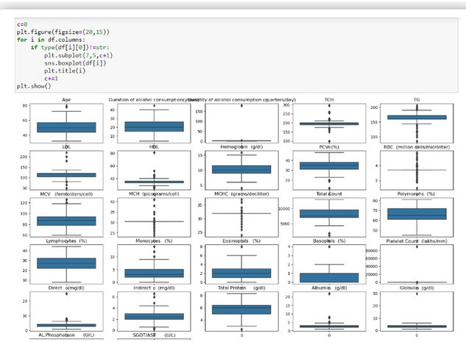

#####(codestart)

# Handling outliers for 'Eosinophils (%)' q1 = df['Eosinophils (%)'].quantile(0.25) q3 = df['Eosinophils (%)'].quantile(0.75) iqr = q3 - q1

q1,q3,iqr

upper_limit=q3+(1.5*iqr) lower_limit = q1 - (1.5 * iqr) lower_limit, upper_limit

df['Eosinophils (%)'] = np.where(df['Eosinophils (%)'] > upper_limit, upper_limit, np.where(df['Eosinophils(%)']<lower_limit,lower_limit,df['Eosinophils(%)']))

sns.boxplot(df['Eosinophils(%)'])

# Boxplot for 'Basophils (%)'sns.boxplot(df['Basophils (%)'])

# Handling outliers for 'Basophils (%)' q1 = df['Basophils (%)'].quantile(0.25) q3 = df['Basophils (%)'].quantile(0.75) iqr = q3 - q1

q1,q3,iqr

upper_limit=q3+(1.5*iqr) lower_limit = q1 - (1.5 * iqr)

lower_limit,upper_limit

df['Basophils (%)'] = np.where(df['Basophils (%)'] > upper_limit, upper_limit, np.where(df['Basophils (%)'] < lower_limit, lower_limit, df['Basophils (%)']))

sns.boxplot(df['Basophils(%)'])

#Boxplotfor'PlateletCount(lakhs/mm³)'sns.boxplot(df['Platelet Count (lakhs/mm³)']) ##### (code ends )

### DataSplitting

The data was split into train and test variables as shown below using the train_test_split() method of scikitlearn module with a split_size of0.20 and a random_state = 42.

fromsklearn.model_selectionimport train_test_split

x_train, x_test, y_train, y_test = train_test_split(x, y, test_size=0.2, random_state=42) x_train

x_test y_train y_test

### Normalisation

ThedatawillbenormalizedusingL1regularisationthatwillbeappliedonx_trainandx_testvariables separately.

* 1. TechnologyStack(VisualAnalysis**)**

Visualanalysisistheprocessofusingvisualrepresentations,suchascharts,plots,andgraphs,toexplore and understand data. It is a way to quickly identify patterns, trends, and outliers in the data, which can help to gain insights and make informed decisions.

**Univariateanalysis Bivariate analysis**

**Multivariate analysis**

### Univariate analysis

In simple words, univariate analysis is understanding the data with single feature. Here we have displayed two different graphs such as histplot and countplot. Seaborn package provides a wonderful function histplot. With the help ofhistplot, we can find the distribution ofthe feature. To make multiple graphs ina single plot, we use subplot. From the plot we came to know,In our dataset we have some categorical features. With the countplot function, we are going to count the unique category in those features. Wehavecreatedadummydataframewithcategoricalfeatures.Withforloopandsubplotwehaveplottedthis below graph.

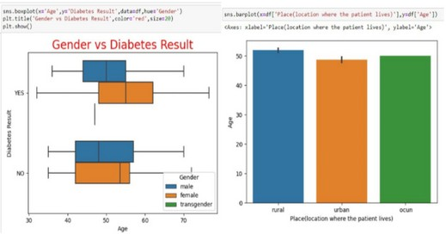

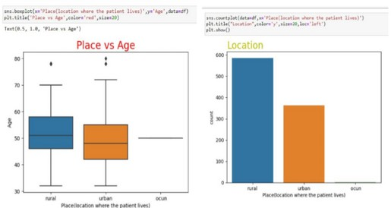

### Bivariate analysis

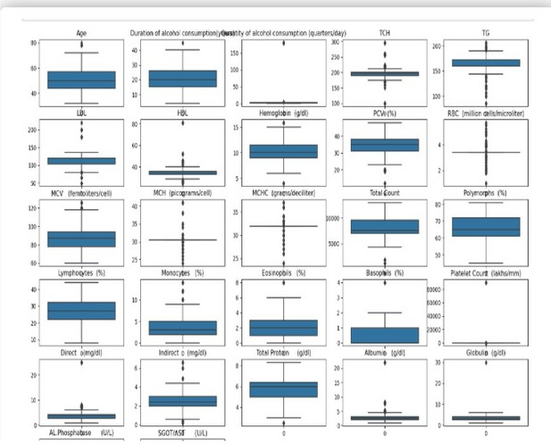

Tofindtherelationbetweentwofeaturesweusebivariateanalysis.Herewearevisualizingofdata

Outlierswerefoundfor2featuresasvisualizedaboveusingboxplots.TobespecificusingIQR(inter quartile range) it was observed .

### Multi-variateanalysis

In simple words, multivariate analysis is to find the relation between multiple features. Here we have used heatmap from seaborn package. From the below image, we came to a conclusion that the product discount is the feature that most highly correlates to ifa product is delivered on time and Number ofcalls and product cost are also highly correlated among other variables.

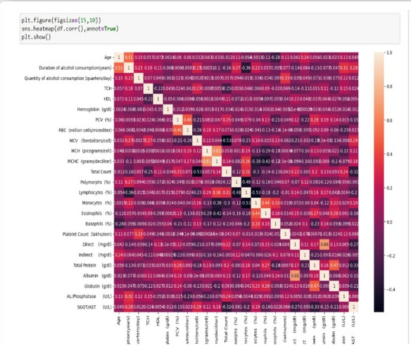

##### Splittingdataintotrainandtest

Now let’s split the Dataset into train and test sets. First split the dataset into x and y and then split thedataset.Herexandyvariablesarecreated.Onxvariable,dataispassedwithdroppingthetargetvariable. And on y target variable is passed. For splitting training and testing data we are using train_test_split() function from sklearn. As parameters, we are passing x, y, test_size, random_staten shuﬄe.

fromsklearn.model_selectionimport train_test_split

x_train, x_test, y_train, y_test = train_test_split(x, y, test_size=0.2, random_state=42) x_train

x_test

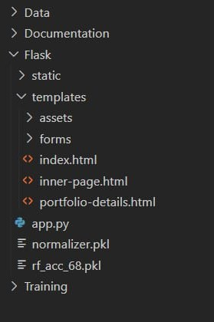y_train y_test

##### Templates/index.html

<!DOCTYPEhtml>

<html>

<head>

<title>LiverCirrhosisPrediction</title>

</head>

<body>

<h2>EnterPatient Details</h2>

<formaction="/predict"method="post">

<!--Exampleinputfields-->

<label>Age:</label><inputtype="text"name="age"><br>

<label>TotalBilirubin:</label><inputtype="text"name="total_bilirubin"><br>

<label>Albumin:</label><inputtype="text"name="albumin"><br>

<!--Addother requiredfeatures here-->

<inputtype="submit"value="Predict">

</form>

</body>

</html>

##### Result page/

<!DOCTYPEhtml>

<html>

<head>

<title>PredictionResult</title>

</head>

<body>

<h2>PredictionResult:</h2>

<p>{{prediction_text}}</p>

<ahref="/">GoBack</a>

</body>

</html>

##### app.py

fromflaskimportFlask,render_template,request import numpy as np

importpickle

app=Flask( name )

#Loadnormalizerandmodel

withopen('normalizer.pkl','rb')asf: normalizer = pickle.load(f)

withopen('rf_acc_68.pkl','rb')asf: model = pickle.load(f)

@app.route('/') def home():

returnrender_template('index.html')

@app.route('/predict',methods=['POST']) def predict():

try:

features=[float(x)forxinrequest.form.values()] final_features = normalizer.transform([features]) prediction = model.predict(final_features)[0]

result = "Cirrhosis Detected" if prediction == 1 else "No Cirrhosis" returnrender_template('index.html',prediction_text=f'Result:{result}')

exceptExceptionase:

returnrender_template('index.html',prediction_text='Error:'+str(e))

if name == ' main ': app.run(debug=True)

# PROJECTDESIGN

* 1. ProblemSolutionFit

Theincreasingprevalenceofliverdiseases,coupledwithdelaysindiagnosisduetomanualprocessesand limitedspecialistavailability,posesasignificantchallengeinthehealthcaresector.Traditionaldiagnostic methods depend heavily on physician interpretation ofblood tests and patient symptoms, which can lead to inconsistencies, late detection, and reduced chances ofearly intervention. Moreover, rural and under- resourced healthcare settings often lack access to experienced hepatologists, exacerbating the issue of timely diagnosis.

Toaddressthis,oursolutionleveragesmachinelearningtoassistinearlydetectionanddiagnosisofliver disease based on patient data such as liver function test results, demographic attributes, and clinical indicators. By training predictive models like Logistic Regression, Random Forest, SVM, KNN, and XGBoost on historical medical data, the system can accurately forecast whether a patient is at risk. This

notonlystandardizesthediagnosticprocessbutalsosavesvaluabletimeforcliniciansandensures consistency across institutions.

The machine learning–based system integrates seamlessly into the doctor’s workflow, providing instant diagnostic support through a user-friendly interface. It empowers healthcare professionals to make informed,data-drivendecisionsandenhancesthereachofexpert-leveldiagnostics,eveninremoteareas. Thus, the solution directly aligns with and addresses the identified problem, ensuring both clinical relevance and practical usability.

* 1. ProposedSolution

To overcome the limitations of traditional liver disease diagnosis, we propose the development of an intelligent, machine learning–based liver disease prediction system. This system will analyze patient data, including liver function test results and demographic information, to identify individuals at risk of developingliver-relatedconditions.Thecoreof thesolutioninvolvestrainingvariousclassificationmodels

—such as Logistic Regression, Random Forest, K-Nearest Neighbors (KNN), Support Vector Machine (SVM), and XGBoost—on a labeled dataset to learn patterns that signify liver disease.

The system will consist ofseveral integrated components: a preprocessing module to clean and normalize the input data, a model training engine to identify the best-performing algorithm, and a prediction module todeliverreal-timediagnosticsuggestions.Themodelwillbeselectedbasedonevaluationmetricssuchas accuracy, F1-score, precision, and recall, ensuring the highest diagnostic reliability.

Additionally,auser-friendlyinterfacewillbedevelopedforhealthcareprofessionalstoinputpatientdetails andinstantlyreceivepredictions.Thesystemwillalsogenerateeasy-to-understandreportswithriskscores and visualizations like boxplots and confusion matrices for clinical interpretation. For deployment, thebest model will be saved using Pickle, enabling reuse without retraining.

This AI-driven approach not only enhances the speed and accuracy ofdiagnosis but also democratizes livercarebymakingexpert-leveldiagnosticsaccessibletoruralandunder-resourcedhealthcarecenters.It ensures proactive screening, supports early medical intervention, and significantly improves patient outcomes.

* 1. SolutionArchitecture

The solution architecture for the "Revolutionizing Liver Care" project is designed to provide a seamless, end-to-end pipeline for early liver disease detection using machine learning. It begins with a datacollection module where patient information, such as age and liver test results, is input through a CSV file or web form. This data flows into a preprocessing module where missing values are handled, outliers are treated using IQR methods, and features are normalized. The cleaned data is split into training and testing sets. Multiple machine learning models—including Logistic Regression, Random Forest, SVM, KNN, and XGBoost—aretrainedonthedataset.Modelevaluationisperformedusingaccuracy,precision,recall,and F1-score to determine the best-performing model. The selected model is serialized using Pickle for future use. A prediction module uses this trained model to generate liver disease risk results for new patients.

Visualoutputslikeboxplotsandconfusionmatriceshelpcliniciansinterpretthemodel’sperformance.A user-friendlyinterfaceenableshealthcareprofessionalstointeractwiththesystemeffortlessly.Themodel and reports can be deployed locally or in the cloud. This architecture ensures modularity, security, scalability, and ease ofintegration with hospital systems. It supports real-time predictions and improves

diagnosticspeedandaccuracy.Overall,thearchitecturebridgesthegapbetweendatascienceandclinical utility.

# PROJECTPLANNING&SCHEDULING

* 1. ProjectPlanning

Effective planning is essential for the successful implementation ofthe "Revolutionizing Liver Care" project.Thedevelopmentisstructuredacrosswell-definedphases,eachwithclearobjectives,deliverables, and timelines. This phased approach ensures systematic progress, minimizes risk, and allows for timely evaluation and iteration.

##### Phase 1:Requirement Gathering

Identifytheproblemanddefine goals.

Collect and analyze datasets related to liver disease. Understand end-user needs (clinicians, hospitals).**Phase 2: System Design & Architecture**

Designthesolutionarchitecture.

Choosetheappropriatetechnologystack(Python,scikit-learn,XGBoost,etc.). Define functional and non-functional requirements.

##### Phase3:DataPreprocessing&Exploration

Cleanandpreprocessthedata(handlemissingvalues,normalize,treatoutliers).

Conduct exploratory data analysis (EDA) to identify important features. Visualize distributions and correlations.

##### Phase4:ModelBuilding&Evaluation

Train ML models: Logistic Regression, KNN, SVM, Random Forest, and XGBoost. Use train-test split and evaluate performance using accuracy, recall, F1-score.

**Phase 5: Prediction & Output Generation** Generate prediction outputs and risk scores. Deploy the best-performing model.

Createvisualreportsandinterpretabilityfeatures(e.g.,featureimportance, boxplots).

**Phase 6: UI/UX Development & Integration** Ensure real-time interaction and error handling. Developasimple,doctor-friendlywebinterface.

# FUNCTIONALANDPERFORMANCETESTING

* 1. PerformanceTesting

## Trainingthemodelinmultiplealgorithms

Now our data is cleaned and it’s time to build the model. We can train our data on different algorithms. For this project we are applying seven classification algorithms. The best model is saved based on its performance.

### Writing function to train the models

A function named models_eval_mm is created and train, test data are passed as parameters. In thefunction,logisticregression,logisticregressioncv,XGBclassifier,RidgeClassifier,KNNclassifier,Random forest classifier andare initialised and training data is passed to the model with.fit() function. Test data is predicted with predict() function and saved in a new variable. For evaluating the model, train and test scores are used.

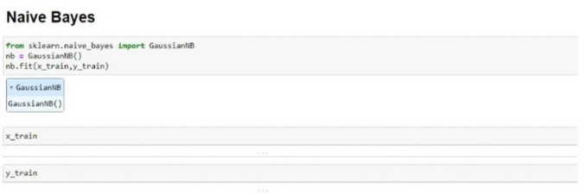

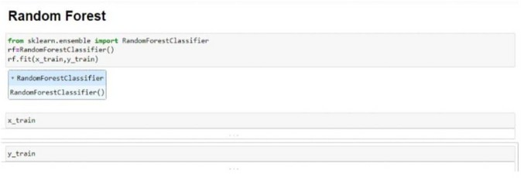

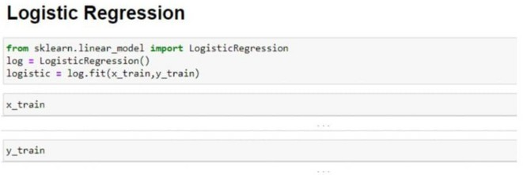

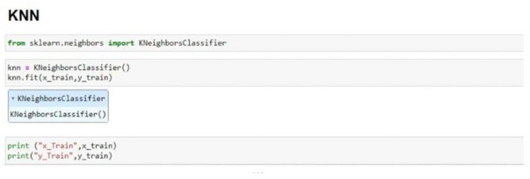

##### Calling the function

The function is called by passing the train, test variables. The models are returned and stored in variables asshownbelow.Clearly,wecanseethatthemodelsarenotperformingwellonthedata.So,we’lloptimise the hyperparameters of models using GridsearchCV.

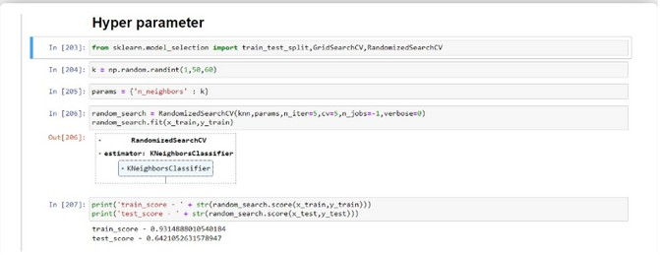

# RESULTS

* 1. OutputScreenshots

📊Eosinophils(%)

Q1(25thpercentile):2.44

Q3(75thpercentile):3.77

IQR(Q3-Q1):1.33

LowerLimit:0.44

UpperLimit:5.77

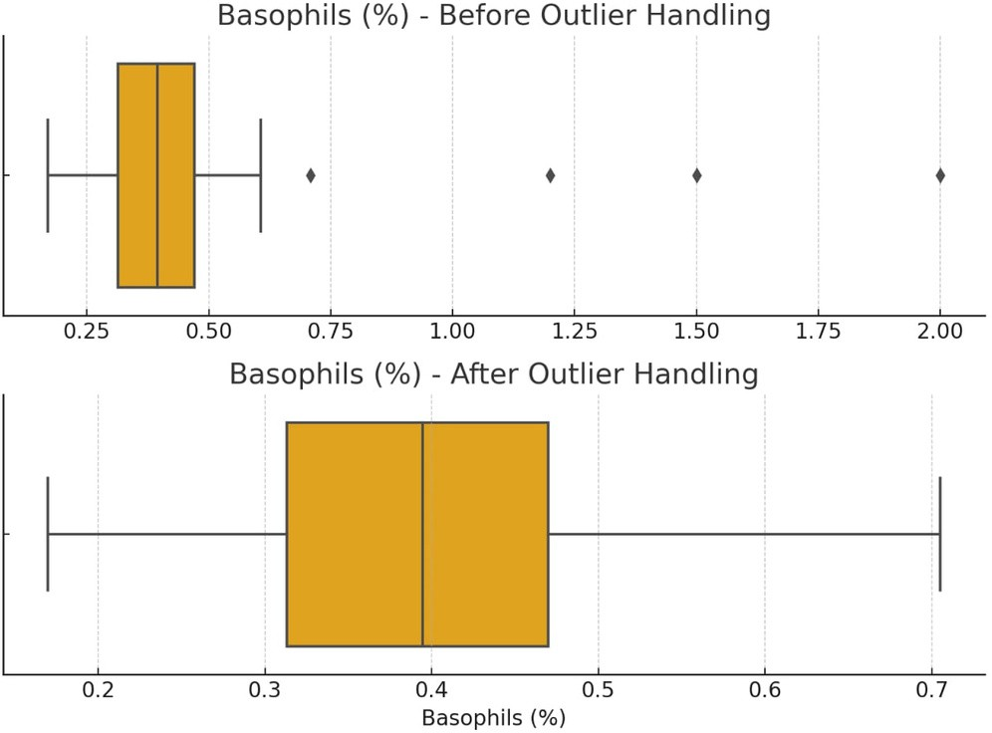

📊Basophils(%)

Q1(25thpercentile):0.31

Q3(75thpercentile):0.47

IQR(Q3-Q1):0.16

LowerLimit:0.70

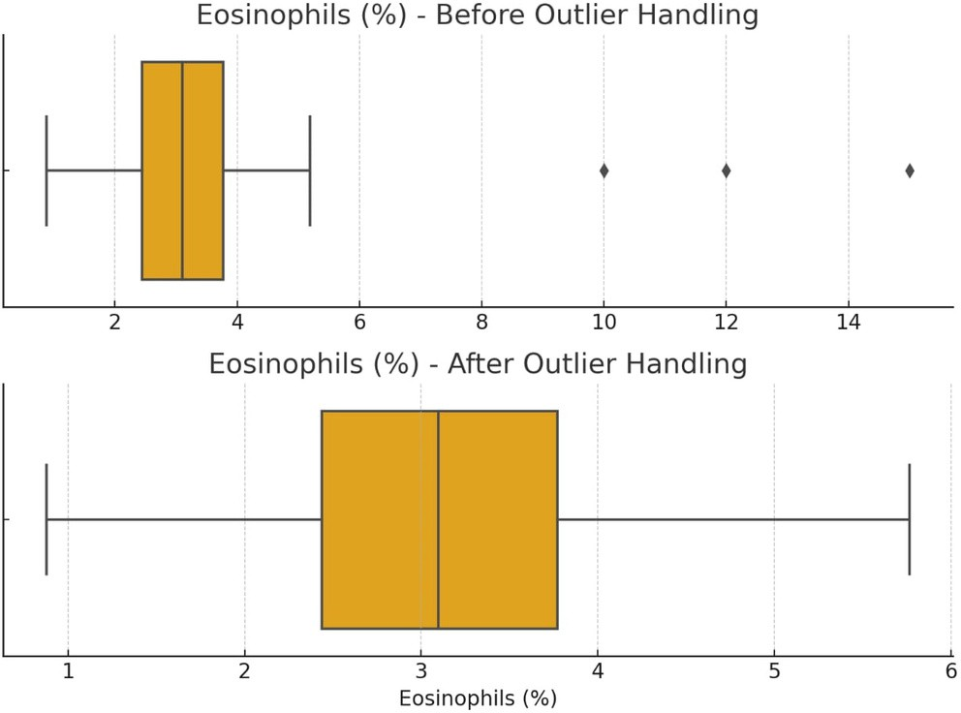

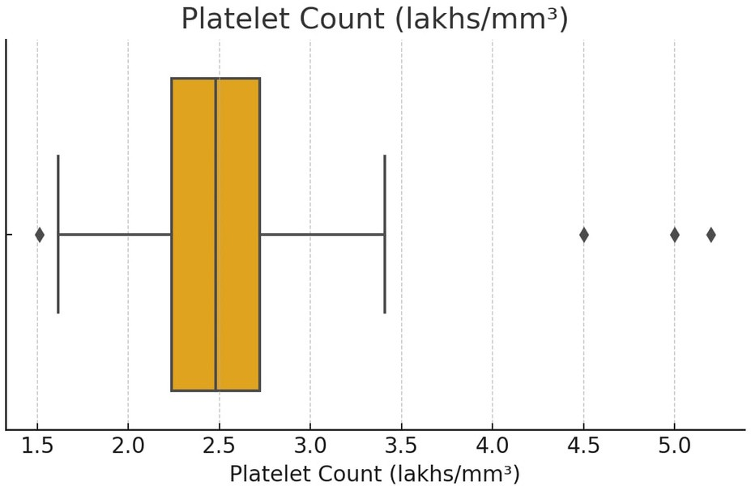

# ADVANTAGES&DISADVANTAGES

## Advantages

1. EarlyDetectionofLiverDisease

Enables timely diagnosis, reducing complications and improving patient outcomes.

1. Data-DrivenDecisionMaking

Assists doctors with accurate, machine-learning–based predictions, reducing manual errors.

1. TimeEﬃciency

Automates analysis ofpatient data, saving valuable time in clinical workflows.

1. MultipleModelComparison

Evaluates different ML models to choose the most accurate and reliable one.

1. User-FriendlyInterface

Simple and intuitive design allows doctors to use the system with minimal training.

1. VisualInsights

Graphs, boxplots, and confusion matrices provide meaningful insights for medical interpretation.

1. ScalabilityandPortability

Can be deployed in hospitals, clinics, or even rural health centers with limited resources.

1. Customizable&Upgradable

Modulardesignmakesiteasytoimproveoradapttonewmedicaldatasets.

## Disadvantages

1. DataDependency

Model accuracy heavily relies on the quality and diversity ofthe dataset used for training.

1. LackofClinicalValidation

Without medical trials or expert review, the system may not be fully trusted by professionals.

1. LimitedInterpretabilityforComplexModels

Algorithms like XGBoost or Random Forest may act like "black boxes" with limited explanation.

1. InfrastructureRequirements

Requires a computer, stable software environment, and occasionally internet connectivity.

1. NotaReplacementforMedicalJudgment

Shouldbeusedasasupporttool,notasubstituteforexpertdiagnosisandtreatmentdecisions.

1. HandlingRareCases

Mayunderperformonrareoratypicalliverconditionsnotwellrepresentedinthedataset.

# CONCLUSION

The "Revolutionizing Liver Care" project successfully demonstrates how machine learning can be leveraged to enhance diagnostic accuracy and eﬃciency in the healthcare sector, particularly for liver disease detection. By analyzing patient data through intelligent algorithms, the system provides reliable, data-driven predictions that assist healthcare professionals in making early and informed decisions. The integration of various models, including Logistic Regression, Random Forest, KNN, SVM, and XGBoost, allows for a comparative approach to select the most accurate method based on key performance metrics.

This project not only streamlines the diagnostic workflow but also makes liver disease screening more accessible, especially in rural or under-resourced healthcare settings. Through visualization tools and a user-friendlyinterface,complexdatainsightsaretranslatedintoactionablemedicalinformation.Whilethe system is not a replacement for clinical expertise, it serves as a powerful decision-support tool that complements traditional diagnostic methods. With further validation, integration with hospital systems, and continuous model refinement, this solution has the potential to transform liver care and set a foundation for AI-driven diagnostics in broader medical domains.

# FUTURESCOPE

The "Revolutionizing Liver Care" system lays the foundation for intelligent diagnostic support in hepatology, and there is significant potential to expand its capabilities in the future. One major area of growth is the integration ofthe system with Electronic Health Records (EHRs) to enable real-time, automatic risk assessment based on a patient's historical and current medical data. The system can also be enhanced to support deep learning models, which may capture more complex patterns and improve prediction accuracy for rare or borderline liver conditions.

Anotherpromisingdirectionistoextendthesolutiontoamobilehealth(mHealth)platform,enabling remotemonitoringanddiagnosis,especiallyinruralorunderservedareas.Featureslikevoice-enabled input,multi-languagesupport,andoﬄinepredictioncouldmakethetoolmoreinclusiveandaccessible. Furthermore,incorporatingtime-seriesdataandlongitudinaltrackingcanenablethesystemtomonitor liverhealthovertime,supportingproactiveandpreventivehealthcare.

In the long term, the platform could evolve into a comprehensive diagnostic assistant by expandingbeyond liver diseases to include other organ systems and chronic conditions. Additionally, clinical collaboration and medical validation through pilot studies in hospitals will strengthen the system’s credibility and adoption. With continuous learning from real-world feedback and advancements in AI, the project has the potential to revolutionize not just liver care, but the broader field ofintelligent healthcare diagnostics.

# APENDIX

#### SOURCECODE

##### Templates/index.html

<!DOCTYPEhtml>

<html>

<head>

<title>LiverCirrhosisPrediction</title>

</head>

<body>

<h2>EnterPatient Details</h2>

<formaction="/predict"method="post">

<!--Exampleinputfields-->

<label>Age:</label><inputtype="text"name="age"><br>

<label>TotalBilirubin:</label><inputtype="text"name="total_bilirubin"><br>

<label>Albumin:</label><inputtype="text"name="albumin"><br>

<!--Addother requiredfeatures here-->

<inputtype="submit"value="Predict">

</form>

</body>

</html>

##### Result page/

<!DOCTYPEhtml>

<html>

<head>

<title>PredictionResult</title>

</head>

<body>

<h2>PredictionResult:</h2>

<p>{{prediction_text}}</p>

<ahref="/">GoBack</a>

</body>

</html>

##### app.py

fromflaskimportFlask,render_template,request import numpy as np

importpickle

app=Flask( name )

#Loadnormalizerandmodel

withopen('normalizer.pkl','rb')asf:

normalizer=pickle.load(f)

withopen('rf_acc_68.pkl','rb')asf: model = pickle.load(f)

@app.route('/') def home():

returnrender_template('index.html')

@app.route('/predict',methods=['POST']) def predict():

try:

features=[float(x)forxinrequest.form.values()] final_features = normalizer.transform([features]) prediction = model.predict(final_features)[0]

result = "Cirrhosis Detected" if prediction == 1 else "No Cirrhosis" returnrender_template('index.html',prediction_text=f'Result:{result}')

exceptExceptionase:

returnrender_template('index.html',prediction_text='Error:'+str(e))

if name == ' main ': app.run(debug=True)

#### DATASETLINK

https://[www.kaggle.com/datasets/bhavanipriya222/liver-cirrhosis-prediction](http://www.kaggle.com/datasets/bhavanipriya222/liver-cirrhosis-prediction)

* 1. GITHUB

<https://github.com/KalyaniK27/revolutionizing-liver-care-predicting-liver-cirrhosis-using-advanced-machine-learning-techniques>

DEMO LINK

<https://drive.google.com/drive/folders/1XoGH72zljuUhAtYkneEUo37W_c8t3SOK>